Rote Learning: What is It? Is It an Outdated Technique?
- Cognitive Skills and Study Methods
- Susan du Plessis
- October 9, 2022


The words rote learning and drill remind us of the 1800s when teachers taught reading, writing, arithmetic, history, grammar, rhetoric, and geography, and students would memorize their lessons.
Then, the teacher would bring them to the front of the room as a class to recite what they’d learned — so the teacher could correct them on things like pronunciation.

Rote learning is “drill and kill”
The term rote learning has come to define bad teaching. The term just seems not to belong in sensitive pedagogy. Good teachers don’t fire off quiz questions and catechize kids about facts. They don’t drill students on spelling or arithmetic. Drilling seems unimaginative and antisocial.
Many of today’s educators look down on rote learning and consider it akin to a form of child abuse. Many consider this form of learning to be “out of style,”¹ “ghastly boring,”² and even “mindless.”³ “Having to spend long periods on repetitive tasks is a sign that learning is not taking place — that this is not a productive learning situation,” says Bartoli.⁴
“In educational circles, sometimes the phrase ‘drill and kill’ is used, meaning that by drilling the student, you will kill his or her motivation to learn,” explains Daniel Willingham, a University of Virginia professor of psychology who has written extensively on learning and memory. “Drilling often conjures up images of late-19th-century schoolhouses, with students singsonging state capitals in unison without much comprehension of what they have ‘learned.’⁵
According to Leon Ho, Founder and CEO of Lifehack, people exposed to rote learning are used to following instructions without having the freedom to think for themselves and reach the same conclusion a different way, or even to explore a different solution altogether. When put in management positions, rote learners may be unable to display leadership skills, which almost always require thinking outside the box and coming up with innovative solutions.⁶

What is rote learning? Does it matter?
A search at Merriam Webster Online defines “rote” as:
1: the use of memory, usually with little intelligence.
2: mechanical or unthinking routine or repetition.
However, the 1850 edition of Noah Webster’s Dictionary defines “rote” as: “To fix in memory by means of frequent repetition.”⁷ That certainly is the essence of what we mean by rote memorization.
What modern educators seem to ignore is that rote memorization is not only the easiest way to learn something; it often is the only way to learn something.⁸ Its purpose is to create automaticity so the child will know something without thinking about it. Below are just a few examples of skills where automaticity plays such an important role that a child will suffer from a learning disability unless they have been automatized:
- A child whose ability to discriminate between left and right has not been automatized will confuse letters like b and d, either when reading or writing, write E instead of 3, or confuse 17 and 71.
.
- There is no substitute for rote in learning arithmetic facts. That knowledge is essential to perform in one’s head or on paper the four functions of arithmetic: adding, subtracting, multiplying, and division. Having a calculator to perform these functions without this basic knowledge in one’s head gives the child no clue as to whether the answer on the calculator is right or wrong.
.
- The child’s lifelong access to the intellectual treasures of centuries depends on his mastery of 26 abstract symbols in an arbitrarily fixed order, i.e., the alphabet. Their ability to organize and retrieve numerous kinds of information from sources ranging from encyclopedias to computers depends on their having memorized that purely arbitrary order.⁹
.
There are many other examples, but this illustrates the importance of rote learning.
Research has shown that rote learning is a consistently effective teaching method when properly applied. For example, a meta-analysis of 85 academic intervention studies with students with learning disabilities found that regardless of the practical or theoretical orientation of the study, the largest effect sizes were obtained by interventions that included systematic drill, repetition, practice, and review.¹⁰

Memorization vital to understanding
In her book, Seven Myths About Education, teacher and educationalist Daisy Christodoulou argues that memorizing doesn’t prevent understanding but rather is vital to it.
“Saying all these negative things about rote learning [versus understanding] is very unhelpful,” she says. “The two things are not in opposition. It’s not that we should spend time on conceptual understanding instead of spending it on learning times tables. It’s by spending time on times tables that you’ll develop the conceptual understanding. Having times tables, basic math facts, phonics, spelling and grammatical structures really well established will allow you to speed up later on.”¹¹
According to Christodoulou, education must take advantage of what we know about memory and how it works. People have working memory and long-term memory. Working memory can manage between three and seven bits of information at any time. Long-term memory is not limited like that, and committing things to long-term memory can be immensely useful.
“You can effectively cheat the limitations of working memory by storing things very well in long-term memory,” says Christodoulou. “If you have to think through 7X3 every time you meet it, you’re taking up space in working memory. Why that is a problem is that as soon as you get a little bit further in mathematics you’re going to hit problems where 7X3 is part of a much bigger problem and that is going to slow down or even stop your ability to solve that bigger problem.
“It’s the same with grammar. If you’re having to stop all the time to think about the mechanics, you’re taking up time and space where you could be thinking about the author’s use of metaphor or whatever. For all of these complex higher-order skills, you need to have as many automatic processes as possible so you can free up space in working memory. It’s by spending time on learning this knowledge that you’ll develop the conceptual understanding.”¹²
.

Edublox offers cognitive training and live online tutoring to students with dyslexia, dysgraphia, dyscalculia, and other learning disabilities. Our students are in the United States, Canada, Australia, and elsewhere. Book a free consultation to discuss your child’s learning needs.

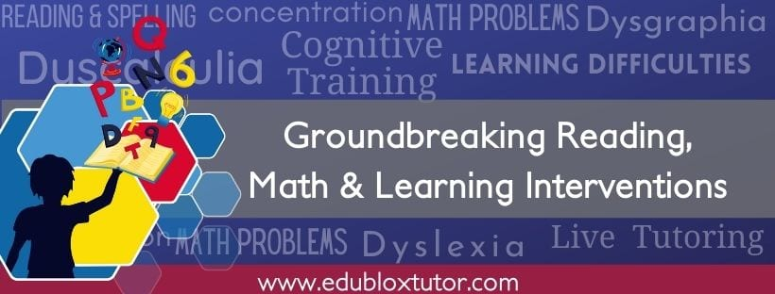

.
References:
1.) Bremmer, J., “What business needs from the nation’s schools,” St. Louis Post-Dispatch, 19 April 1993.
2.) Bassnett, S., “Comment,” Independent, 14 October 1999.
3.) Dixon, R., & Carnine, D., “Ideologies, practices, and their implications for special education,” Journal of Special Education, 1994, vol. 28, 360.
4.) Bartoli, J. S., “An ecological response to Coles’s interactivity alternative,” Journal of Learning Disabilities, 1989, vol. 22(5), 292-297.
5.) Heffernan, V., “Drill, baby, drill,” The New York Times Magazine, 16 September 2010.
6.) Ho, L.,“12 Reasons why rote learning isn’t effective in learning,” Lifehacks.org.
7.) Blumenfeld, S., “The importance of rote learning: Behind the scenes,” Practical Homeschooling, March-April 2000.
8.) Ibid.
9.) Sowell, T., Inside American Education (Englewood Cliffs: Julian Messner, 1993).
10.) Heward, W. L., “Ten faulty notions about teaching and learning that hinder the effectiveness of special education,” Journal of Special Education, January 2003.
11.) Faller, G., “Rote learning is bad – and other myths about education,” The Irish Times, 13 May 2014.
12.) Ibid.

