PROOF POINTS: Flashcards prevail over repetition in memorizing multiplication tables
Evidence builds for “spaced retrieval practice” in classrooms
by JILL BARSHAYOctober 30, 2023
- Click to share on Twitter (Opens in new window)A study published in 2023 in the journal of Applied Cognitive Psychology documented that second graders memorized more multiplication facts when they practiced using flashcards rather than by repeating their times tables aloud. Credit: Matt McClain/The Washington Post via Getty Images
Young students around the world struggle to memorize multiplication tables, but the effort pays off. Cognitive scientists say that learning 6 x 7 and 8 x 9 by heart frees up the brain’s working memory so that students can focus on the more demanding aspects of problem solving.
Math teachers debate the best way to make multiplication automatic. Some educators argue against drills and say fluency will develop with everyday usage. Others insist that schools should devote time to helping children memorize times tables.
Even among proponents of memorization, it’s unclear which methods are the most effective. Should kids draw their own color-coded tables and study them, or copy their multiplication facts out dozens of times? Should they play multiplication songs and videos? Should they learn mnemonic tricks, like how the digits of the multiples of nine add up to nine (1+8, 2+7, 3+6, etc.)? My daughter’s gym teacher used to make students shout “7 x 5 is 35” and “6 x 8 is 48” as they did jumping jacks. (It was certainly a way to make jumping less monotonous.)
To help advise teachers, a team of learning scientists compared two common methods: chanting and flashcards.
The 2022 experiment took place in four second grade classrooms in the Netherlands. The teachers began by delivering a lesson on multiplying by three. Using the same scripted lesson, they explained multiplication concepts, such as: “If I grab three apples, and I do this only one time, how many apples do I have?”
After the lesson, half the classrooms practiced by reciting equations displayed on a whiteboard: “One times three is three, two times three is six…” through to 10. The other half practiced with flashcards. Students had their own personal sets with answers on the reverse side. Both groups spent five minutes practicing three times during the week for a total of 15 minutes. (More details on the experiment’s design here.)
When the teachers moved on to multiplication by fours, the groups switched. The chanters quizzed themselves with flashcards, and the flashcard kids started chanting. All the students practiced memorizing both ways.
The results added up to a clear winner.
On a pre-test before the lesson, the second graders got an average of three math facts right. Afterwards, the chanters tended to double their accuracy, answering six facts correctly. But the flashcard users averaged eight correct. Students were tested again a full week later without any additional practice sessions, and the strong advantage for flashcard users didn’t fade. It was a sign that flashcard practice not only produces better short-term memories, but also better long-term ones – the ultimate goal.
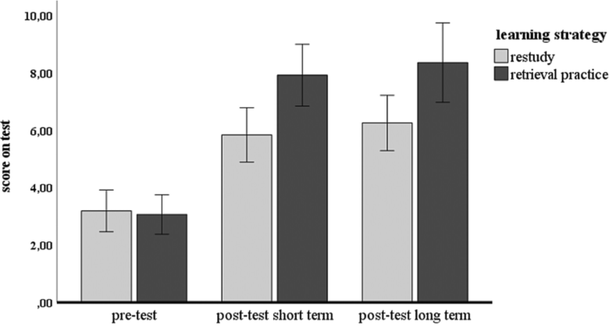Students scored higher on a multiplication test after practicing through flashcards (retrieval practice) than by chanting aloud (restudy). Source: Figure 1 of “The effect of retrieval practice on fluently retrieving multiplication facts in an authentic elementary school setting,” (2023) Journal of Applied Cognitive Psychology.
The study, “The effect of retrieval practice on fluently retrieving multiplication facts in an authentic elementary school setting,” was published online in October 2023 in the journal Applied Cognitive Psychology. Though a small study of 48 students, this classroom experiment is a good example of the power of what cognitive scientists call “spaced retrieval practice,” in which the act of remembering consolidates information and helps the brain form long-term memories.
Retrieval practice can seem counterintuitive. One might think that students should study before being assessed or quizzing themselves. But there’s a growing body of evidence that trying to recall something is itself a powerful tool for learning, particularly when you are given the correct answer immediately after making a stab at it and then get a chance to try again. Testing your memory – even when you draw a blank – is a way to build new memories.
Many experiments have shown that retrieval practice produces better long-term memories than studying. Flashcards are one way to try retrieval practice. Quizzes are another option because they also require students to retrieve new information from memory. Indeed, many teachers opt for speed drills, asking students to race through a page of multiplication problems in a minute.
Flashcards can be less anxiety provoking, provide students immediate feedback with answers on the reverse side and allow students to repeat the retrieval practice immediately, running through the deck more than once. Still, kids are kids and they easily drift off task during independent practice time. With a timed quiz, the teacher can be more confident that everyone has benefited from a round of retrieval practice. I’d be curious to see flashcards and quizzes pitted against each other in a future classroom experiment.
As charming as multiplication songs are – I have a soft spot for School House Rock and my editor fondly recalls her Billy Leach multiplication records – they are unlikely to be as effective as flashcards because they don’t involve retrieval practice, according to Gino Camp, a professor of learning sciences at Open University in the Netherlands and one of the researchers on the study.
That doesn’t mean we should jettison the songs or all the other memorization methods just because some aren’t as effective as others. Researchers may eventually find that a combination of techniques is even more powerful. Still, there are limited minutes in the school day, and knowing which learning methods are the most effective can help everyone – teachers, parents and students – use their time wisely.
This story about multiplication flashcards was written by Jill Barshay and produced by The Hechinger Report, a nonprofit, independent news organization focused on inequality and innovation in education. Sign up for the Hechinger newsletter.

Related articles

