Discuss these animals like a Zoologist.

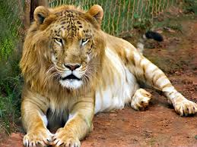
Name: Lion
Eats: Meat
Lives: Africa

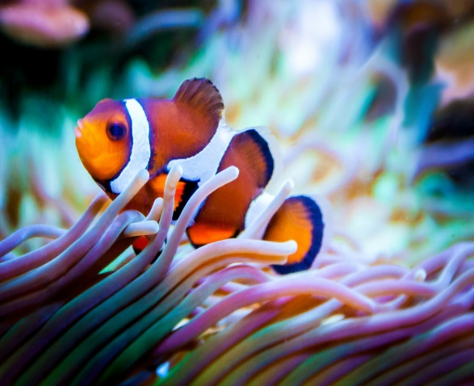
Name: Clown fish
Eats: Plankton and algae
Lives: Indian and Pacific Oceans and the Red Sea

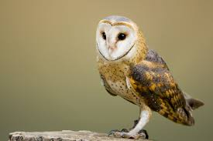
Name: Barn owl
Eats: small mammals like mice and voles
Lives: Every continent except Antarctica

