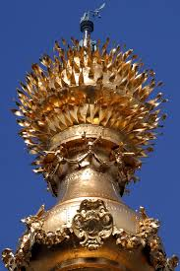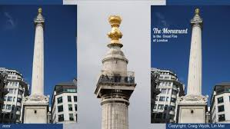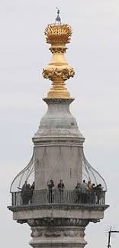

The Monument stands at the junction of Monument Street and Fish Street Hill in the City of London. It was built between 1671 and 1677 to remember the Great Fire of London and to celebrate the rebuilding of the City.
The fire began in a baker’s house in Pudding Lane on Sunday 2nd September 1666 and was finally put out on Wednesday 5th September, after destroying the greater part of the city. Although there was little loss of life, the fire brought all activity to a halt, having destroyed or severely damaged thousands of houses, hundreds of streets, the city’s gates, public buildings, churches and St. Paul’s Cathedral. The only buildings to survive in part were those built of stone, like St. Paul’s and the Guildhall.
As part of the rebuilding, it was decided to put up a permanent memorial of the Great Fire near the place where it began. Sir Christopher Wren, Surveyor General to King Charles II and the architect of St. Paul’s Cathedral, and his friend and colleague, Dr Robert Hooke, provided a design for a huge column in the antique tradition. They drew up plans for a column containing a stone staircase of 311 steps leading to a viewing platform. This was surmounted by a drum and a copper urn from which flames emerged, symbolizing the Great Fire. The Monument, as it came to be called, is 61 metres high – the exact distance between it and the site in Pudding Lane where the fire began.

