Phonics – Week 1
As your child currently has a picture book and is beginning to use sound blending books, I have put together some activities that will increase their confidence and blending skills.
Monday
Speed sounds lesson – Set 1 9:30am:
https://www.youtube.com/channel/UCo7fbLgY2oA_cFCIg9GdxtQ
Practise writing the sound of the day in your workbook.
Can you think of two words that start with the sound of the day? Write them in your workbook, making sure you sound out the word e.g. c-a-t. Then find as many objects as you can around the house that start with the sound of the day.

Tuesday
Speed sounds lesson – Set 1 9:30am:
https://www.youtube.com/channel/UCo7fbLgY2oA_cFCIg9GdxtQ
Practise writing the sound of the day in your workbook.
Can you read the following words to an adult:
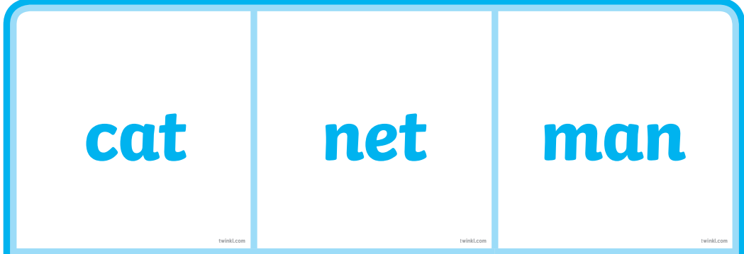
Practise writing them in your workbook once you have read them correctly. Sound out each word as you write it.
Wednesday
Speed sounds lesson – Set 1 9:30am:
https://www.youtube.com/channel/UCo7fbLgY2oA_cFCIg9GdxtQ
Practise writing the sound of the day in your workbook.
Look at the pictures below. Describe them to an adult, then write their names in your workbook. Sound each one out carefully.
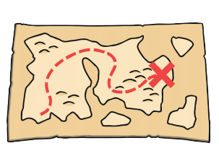

Thursday
Speed sounds lesson – Set 1 9:30am:
https://www.youtube.com/channel/UCo7fbLgY2oA_cFCIg9GdxtQ
Practise writing the sound of the day in your workbook.
Practise your flashcards using the link below and selecting phase 2.
https://www.phonicsbloom.com/uk/game/flash-cards?phase=2
Read your red words with an adult and think of a sentence with each red word in it. E.g.
The cat sat in the sun.

Friday
Speed sounds lesson – Set 1 9:30am:
https://www.youtube.com/channel/UCo7fbLgY2oA_cFCIg9GdxtQ
Practise writing the sound of the day in your workbook.
Play Buried Treasure using the link below:
https://www.phonicsplay.co.uk/BuriedTreasure2.html
Select phase 2 and then revise all phase 2.
The aim of the game is to sound and read each word. If it is a real word drag it to the treasure chest and if it is a made up word drag it to the bin. See how many words you can read correctly.

