Please use the follow link to create your own free account https://www.oxfordowl.co.uk/
This will give you access to Read Write Inc resources that can be used to assist your child in developing their reading skills.
Once you have entered the site please click ‘join us’ as shown below and complete the steps that follow to register.
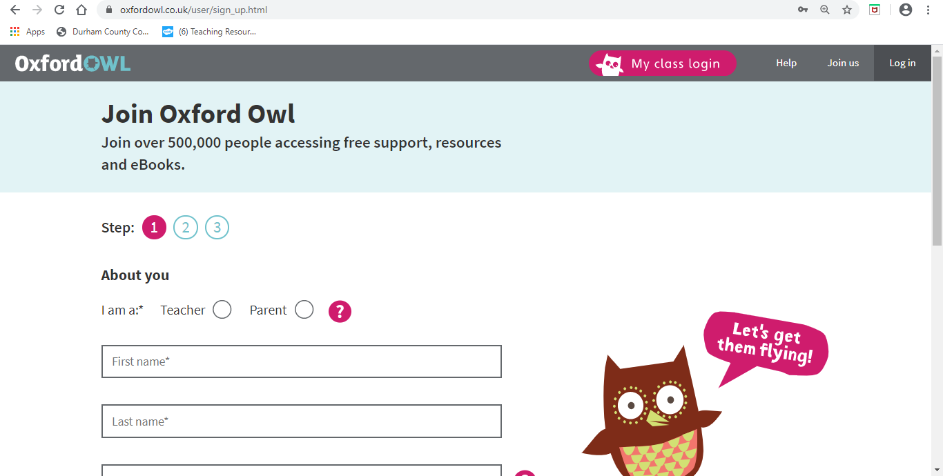

Once you have completed the registration select ‘Oxford Owl for Home’ and ‘enter site’.
Once you have done this there is a tab across the top of the page. Please select ‘Books’. This will provide a drop down menu. Please select ‘ebook library’ (see below). 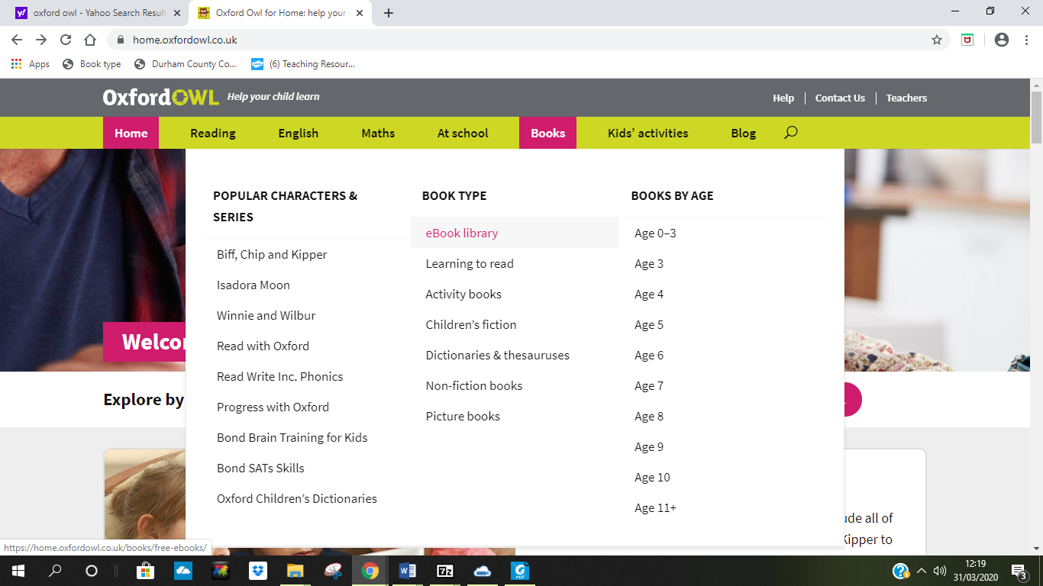
You will see a heading ‘Jump straight in’. Please select ‘ebooks for age 4 – 5’ and scroll down until you see the screen below.
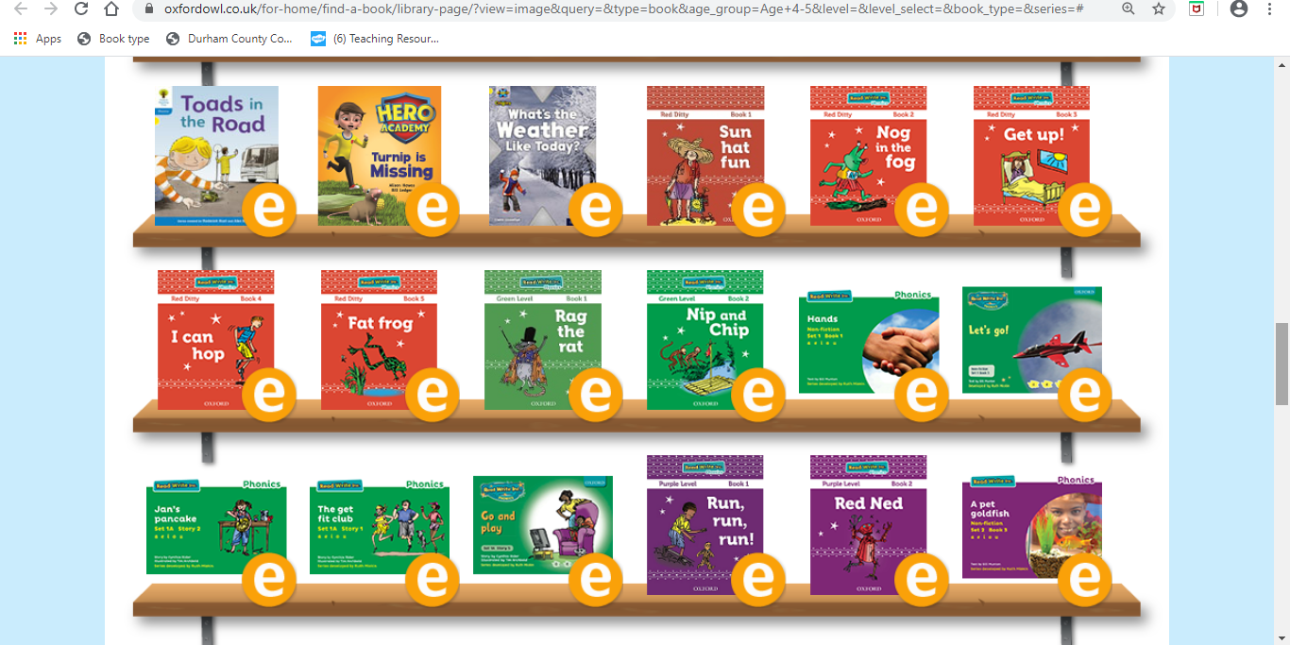

These books are matched to your child’s home reading book and are therefore appropriate for the level they are working at. Please select book 1 in the colour that matches your child’s home reading book. It is IMPORTANT that you do not select a different coloured book at this time. However, we can review your child’s book in the coming weeks if necessary. Activities will be set that matching these books, each week. If your child has a sound blending book they should start reading the red book provided online. If you are unsure as to which book your child should be sing, then please let me know using the email address listed below.

If you have any problems with this please email montalbo@durhamlearning.net

