Maths Worksheet 1
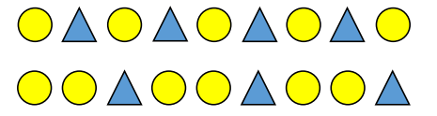
Can you tell an adult what you notice about the patterns below? What is the same about them and what is different?

Can you continue the patterns below? You could draw them out in your workbook and then continue them?

Can you draw your own repeating patterns using the shapes used above? Can you tell an adult what your pattern is using the names of the shapes?

