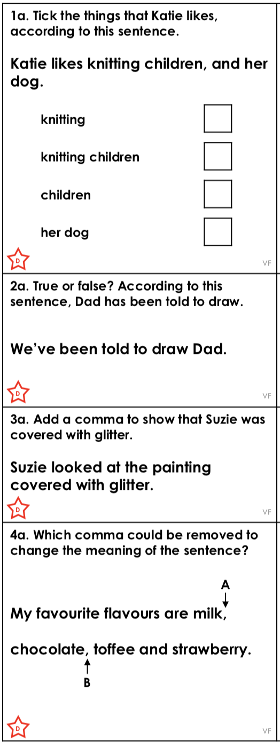
Using Commas to Clarify Meaning

