Dough Disco

Dough Disco is something that we do in nursery a few times a week. It is a fun activity which combines the use of play dough with a series of hand and finger exercises designed to improve fine muscle control. The movements develop children's fine and gross motor dexterity, hand-eye coordination and self-esteem.
Take a look at Shonette’s Dough Disco video using the link below. You can watch her demonstrating some of the dough disco moves that we use in our sessions. You can follow the video or you can have fun making up your own routine using or adapting the key moves just like we do at nursery.
https://www.youtube.com/watch?v=3K-CQrjI0uY
Finger names:
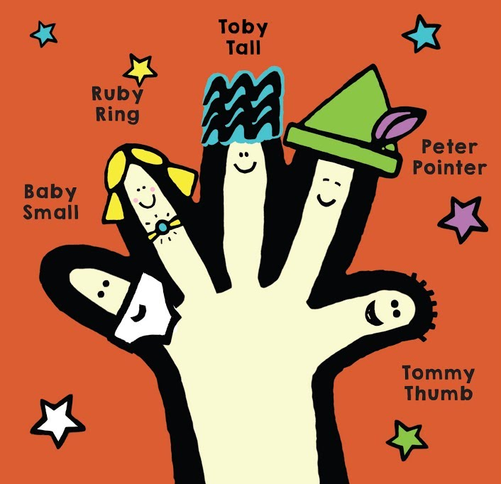
Are you ready to go to the dough disco?

- Get a ball of dough about the size of a golf ball.
- Choose your favourite piece of funky music and turn the volume up.
- Have fun exercising at the dough disco!

Dough disco moves:
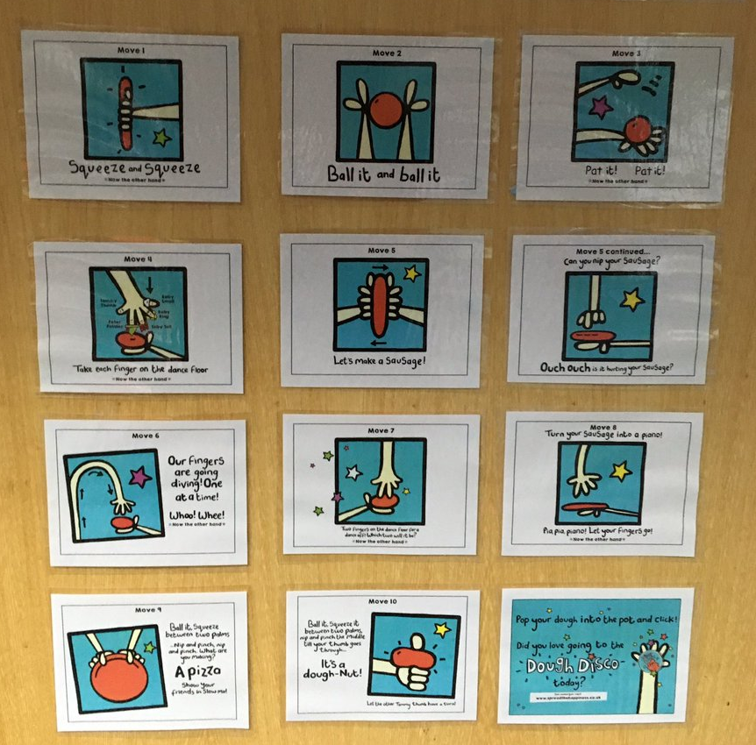

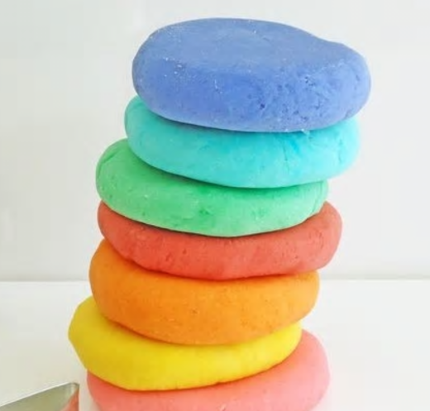 Homemade Playdough Recipe
If you don’t have any playdough you could always make your own. This is the recipe that we use in nursery. The children help us to measure out and mix the ingredients before we cook it on the hob.
